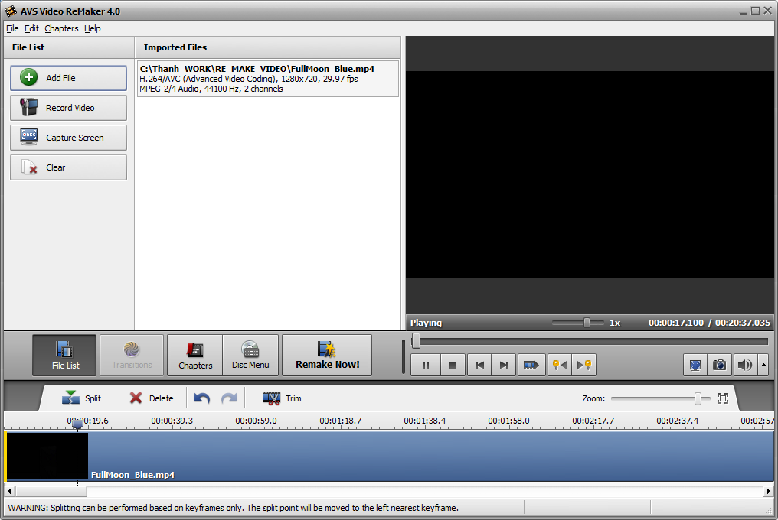

The screen window did not show the picture, it is just black out

How do I avoid this issue ?

