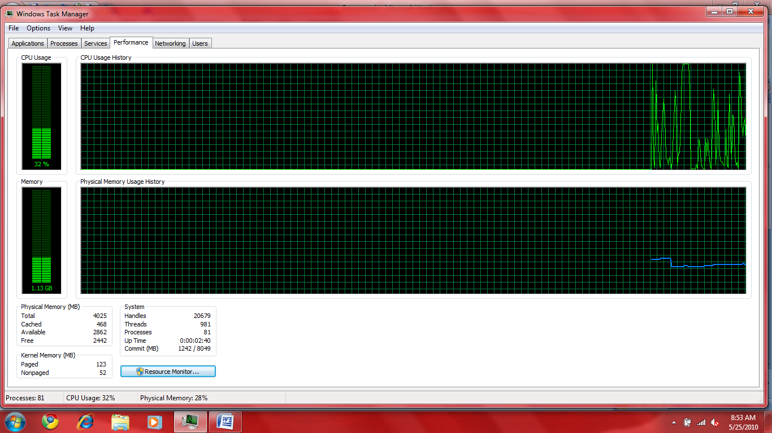
Above screen shot is right after I restarted the computer.
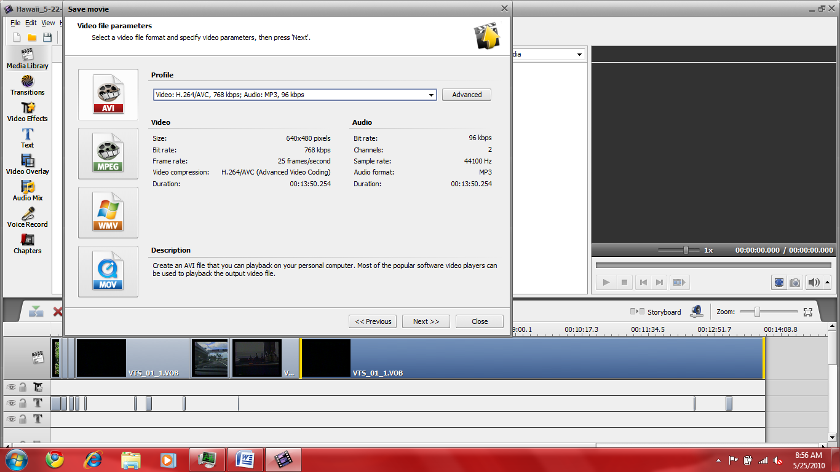
Above screen shot shows the size of the video file and the format I am converting to.
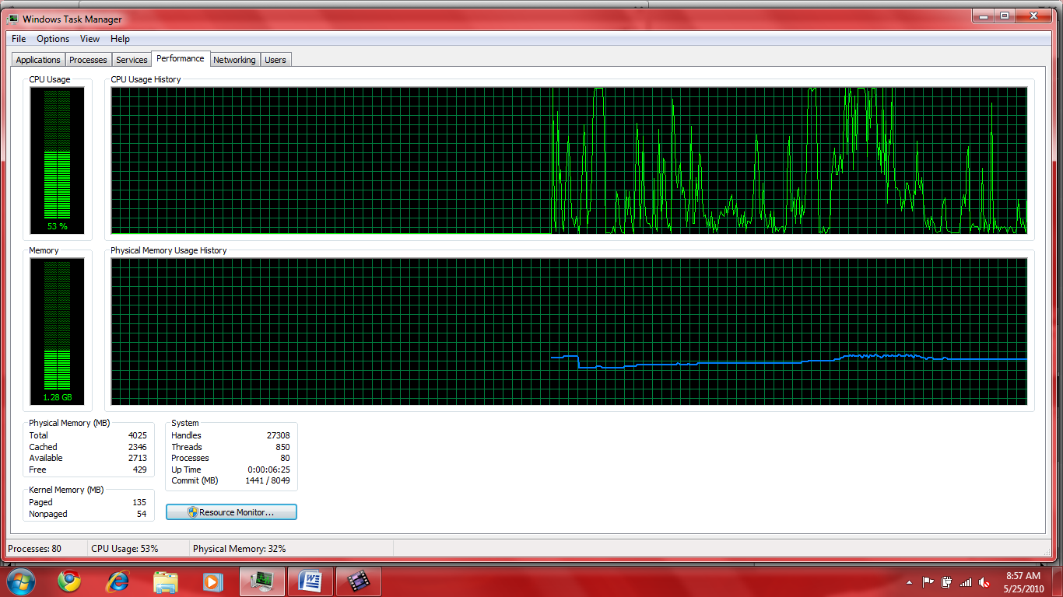
Above screen shot shows the system performance right after I started converting the file through the “Save Movie” option.
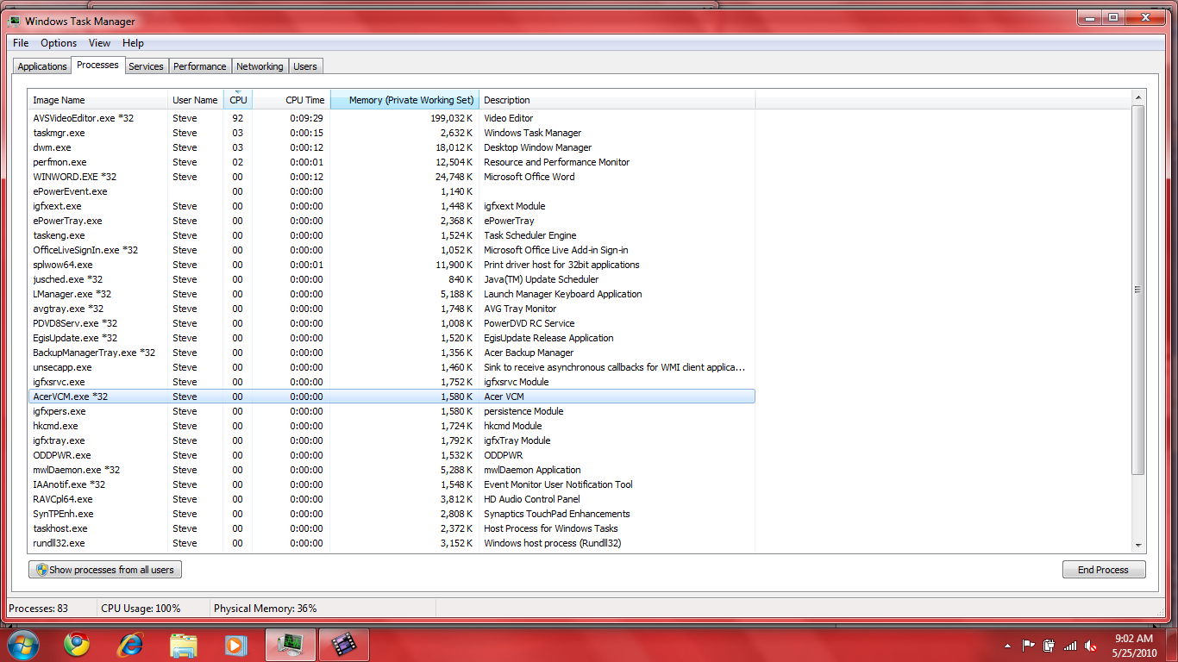
Above screen shot shows the performance after about 10 minutes of the “Save Movie” process.
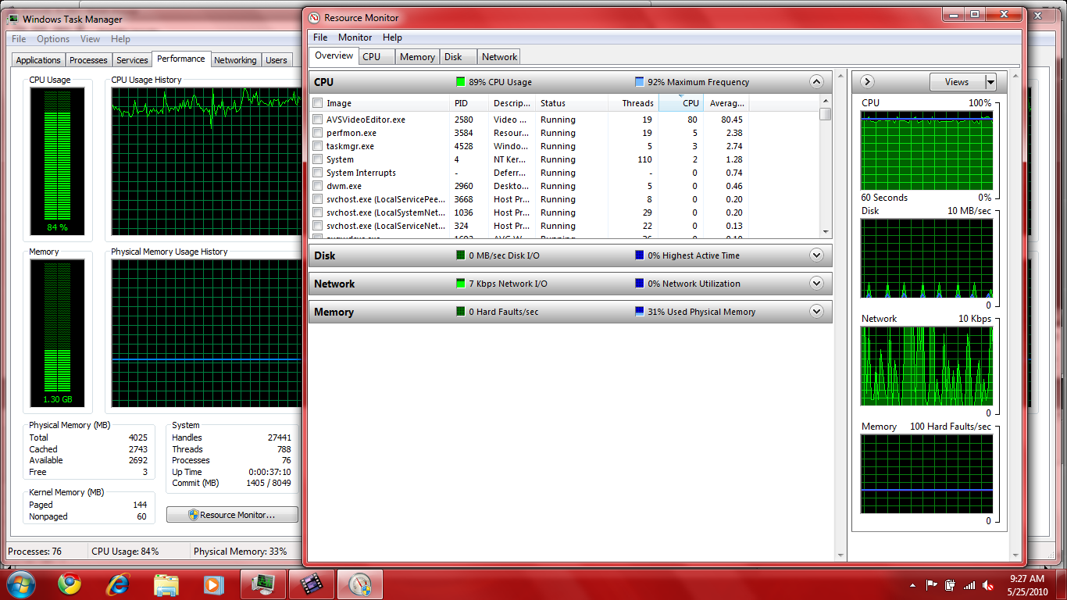
Above screen shot shows the performance about 50% through the “Save Movie” process.
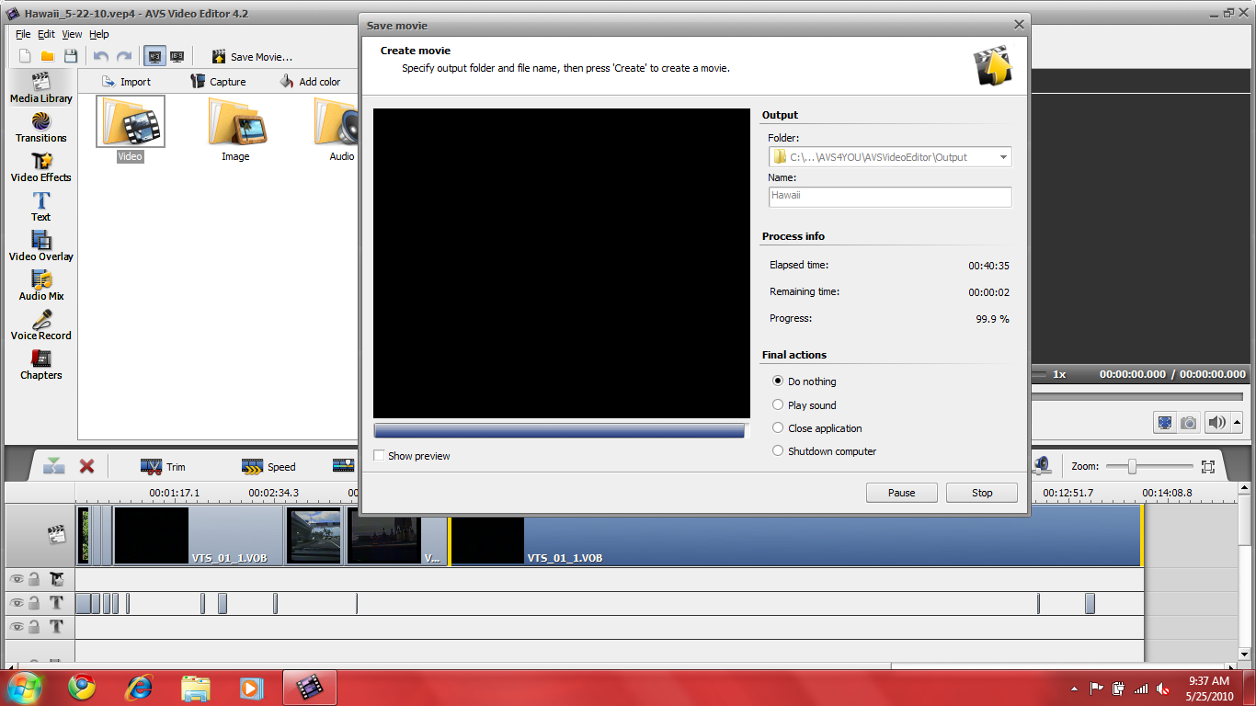
Above screen shot shows the “Save Movie” process took 40 minutes for converting a 14 minute movie. The process did complete where before it would hang around 40%.
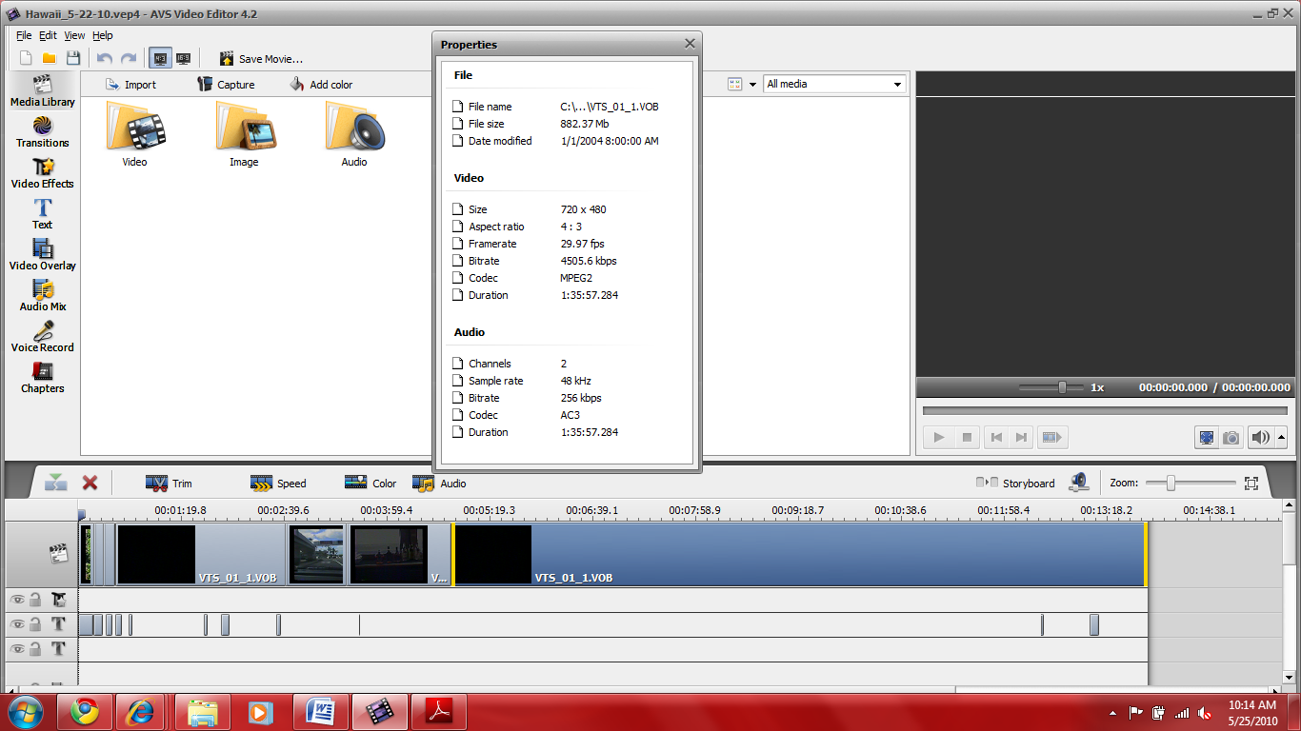

The above shows the results when I right mouse clicked on the “Line for Main Video” and selected “Properties.

