How to convert VHS tapes to DVD format?
- Introduction
- Step 1: Download and install AVS Video Editor
- Step 2: Launch AVS Video Recorder and select video format
- Step 3: Assign an output folder
- Step 4: Define video device input
- Step 5: Start Capture
- Step 6: Edit the created video and produce DVD or other video file

Introduction
You are likely to have the boxes of home video VHS tapes that might contain different events of your life, exclusive musical gigs filmed or some other incredible things you witnessed years ago. It's time to breathe new life to them and bring them up to date. The idea is to capture your video using AVS Video Recorder first and then convert and burn it onto a DVD. Rely on the guide and you will meet no difficulties.

Step 1: Download and install AVS Video Editor
Follow the link below to download AVS Video Editor
http://download.avs4you.com/distributives/AVSVideoRecorder.exe

After the download is finished, run the AVSVideoEditor.exe file and follow the installation wizard instructions.

Step 2: Launch AVS Video Recorder and select video format

Note: first of all you will have to deal with connecting your VHS recorder/player to the computer using a video capture device as a go-between:
- If you use an external video capture board supplied with RCA and S-Video jacks, the best way to link the devices is to connect the VHS recorder/player S-Video output with the video capture board S-Video input using the corresponding cable so to relay a video signal. To relay an audio signal use an RCA cable, connecting your VHS recorder/player RCA output with the video capture device RCA input but employing white and red jacks only. And then use a USB cable to connect the external video capture board to the computer USB port.
- If you have a DV-camera and your computer system is supplied with an IEEE 1394 port then connect your VHS recorder/player to the DV camera just in the same way as it has been described above and then connect the DV camera IEEE 1394 port marked as DV In-Out with the computer IEEE 1394 port using the corresponding cable.

Attention! Actions relating to connecting devices should be done when they are off.
For all the details concerning the possible ways of connecting devices, please, refer either to the User Manuals bundled with them or manufacturer support team.

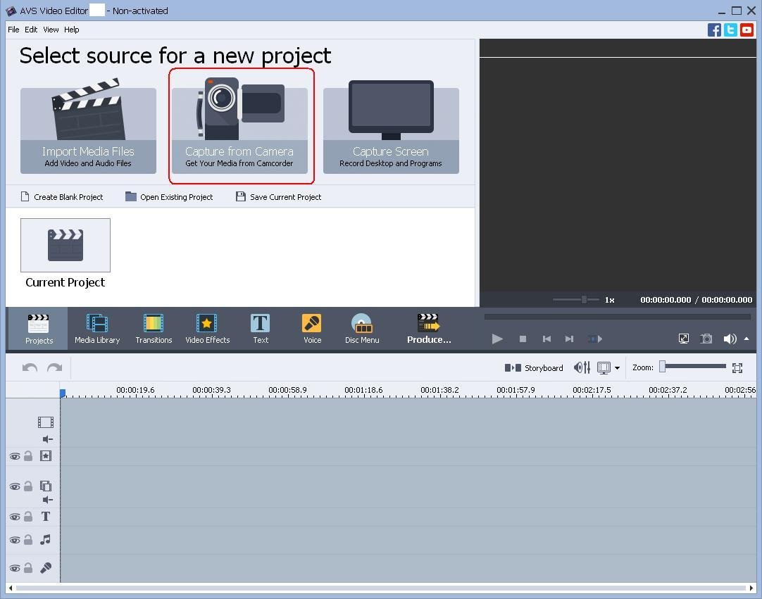
Run the AVS Video Editor executable using the desktop shortcut or the Programs section of the Start menu. Press the Capture from Camera button to lanch AVS Video Recorder

Make sure you work with the Capture tab. By default output video format is set to Recommended (MPEG-2), since your final goal is to have your video in DVD format, that suits fine although there is no reason why you should not select Native or MPEG-2 (with some other presets):

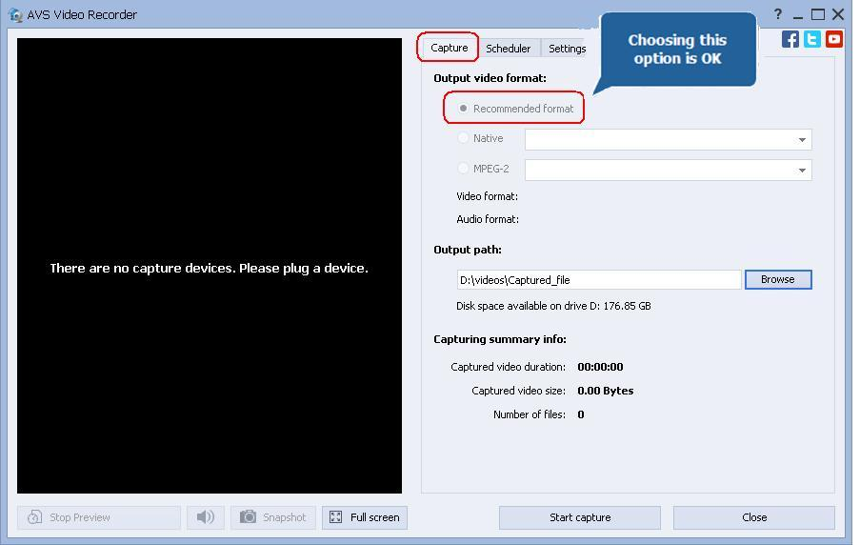

Step 3: Assign an output folder

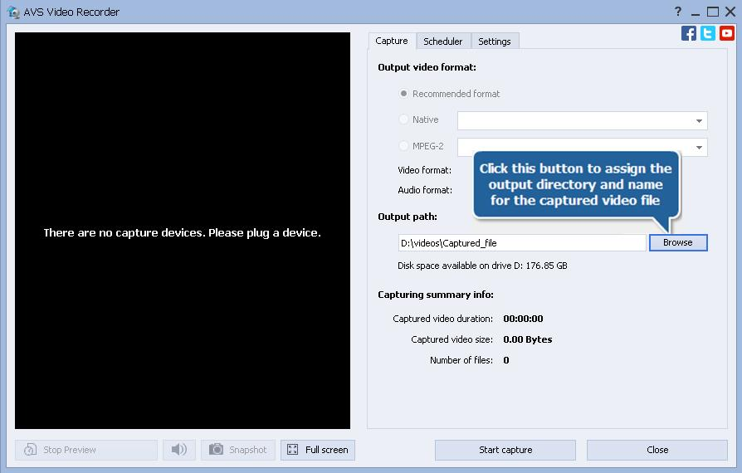
Now define where the captured video should be saved to. Click from the Output path section:

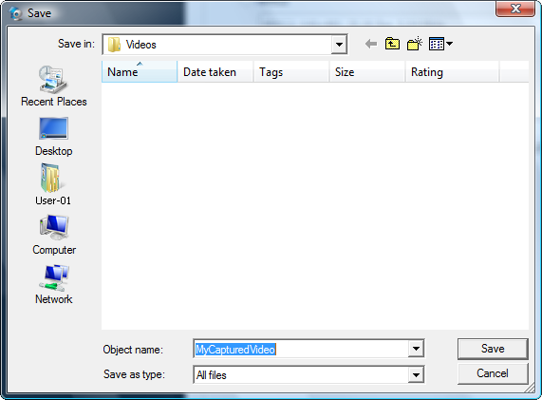
Choose a directory to place the captured video in and name the file, press Save
Step 4: Define video device input

Switch to the Settings tab. Drop down the Video Device Input control and choose either the Composite option in case your VHS player is connected to the capture device using an RCA input or the S-Video option if you preferred an S-Video jack:
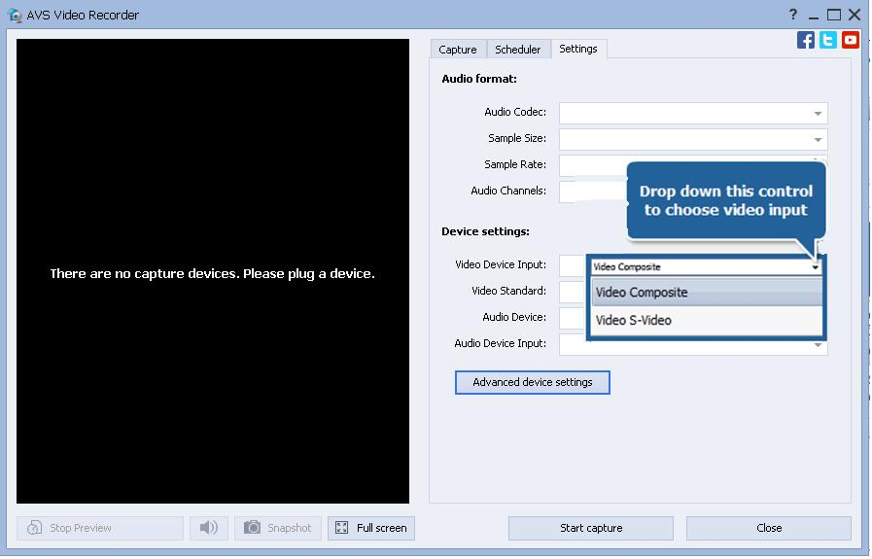

Step 5: Start Capture

Note: before starting capture switch your VHS recorder/player on and check whether a VHS cassette is inserted into its compartment. If you use a DV camera as a capture device then:
- Switch the DV camera on.
- Make sure its cassette compartment does not contain a cassette.
- Enable the DV camera AV to DV feature (refer to User manual for details) and then switch it to playback mode.
Press the Start capture button of AVS Video Recorder and begin the VHS recorder/player tape playback. You can stop capture by pressing the Stop Capture button which will replace the Start Capture button immediately after clicking it:

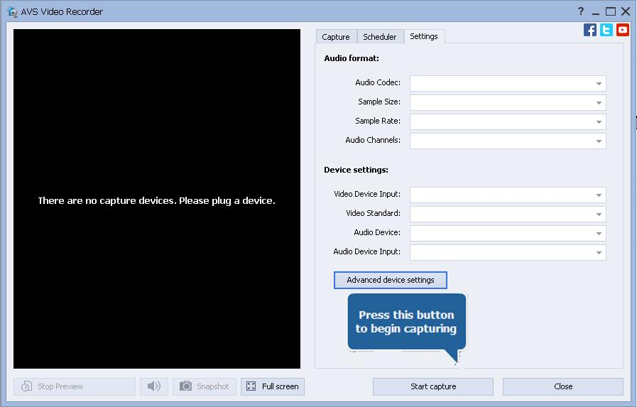

Note: pressing the Stop Capture button of AVS Video Recorder won't stop the VHS tape playback, you should do it yourselves.

Step 6: Edit the created video and produce DVD or other video file.
When you finish capturing video, press the Exit button in AVS Video Recorder bottom right corner to return to AVS Video Editor. You will find your captured video in the Video category of the Media Library:
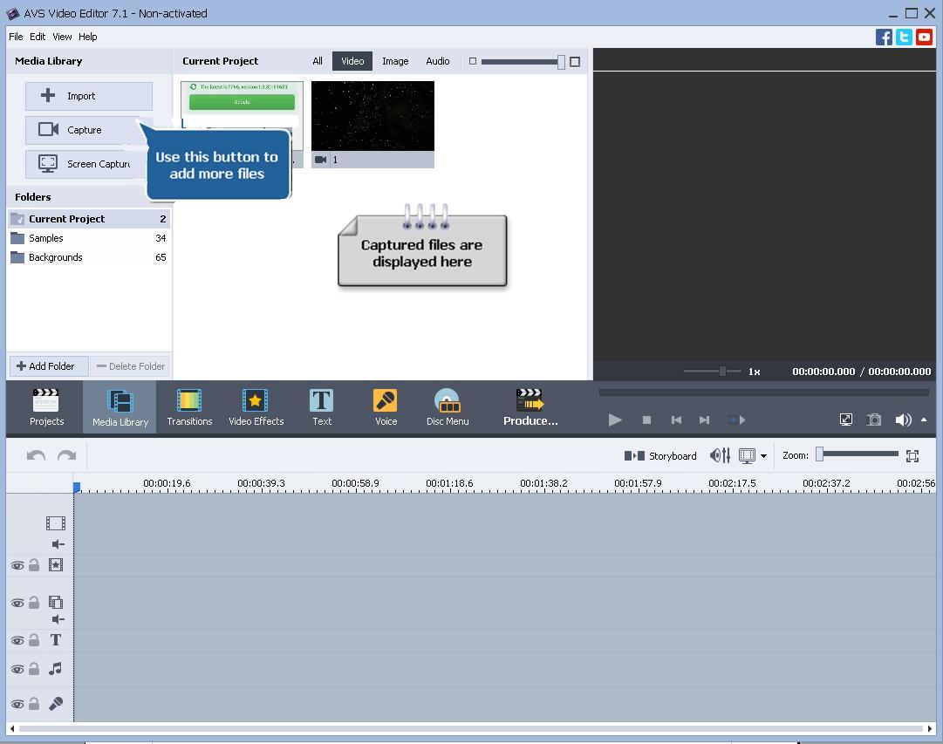

Follow the link below to find the detailed instructions on how to produce your video into a video format: http://onlinehelp.avs4you.com/AVS-Video-Editor/Features/SavingVideos/index.aspx

